Courtney Elmendorf March 27, 2014
Coordinating Seminar

Geogebra Lesson: Graphing Tangent Lines and Derivative Functions

Topic: Graphing the Derivative of a Trig Function

Step 1: Click on the arrow to the left of the word “Graphics” and then click on the picture of the grid, , to display gridlines.

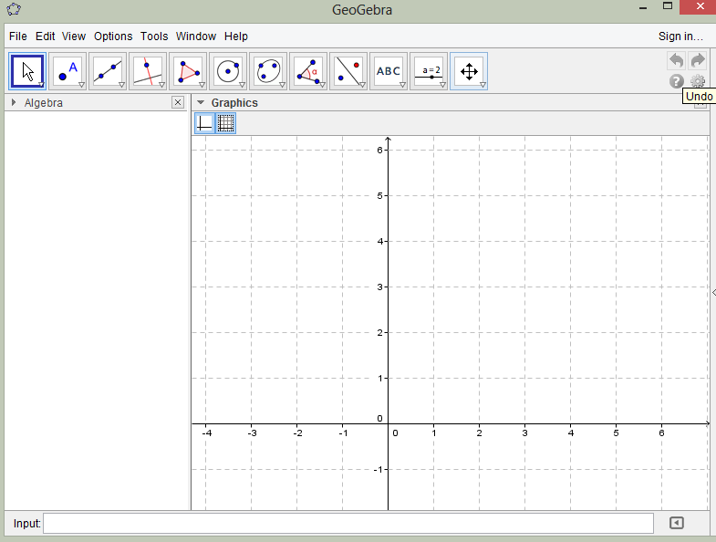

Step 2: Go to the input bar and type the function: f(x)=(a)cos(x) and press enter.
Note: You must type in the function f(x) exactly as displayed above. You must have parentheses around the “a” and “x,” otherwise the program will not graph the function correctly.

Step 3: After typing in the function and clicking “enter,” the following dialogue box will appear:
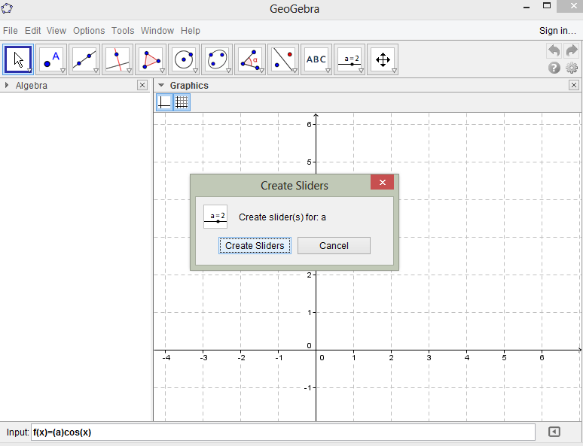

Then, click the “create sliders” button.

Step 4: Go to the new point tool, , and click on it.

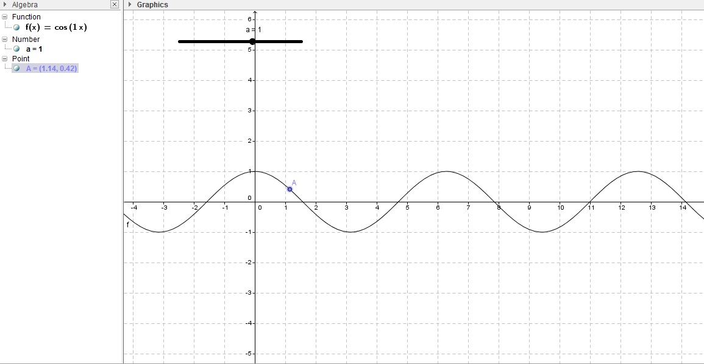
Step 5: Highlight the curve by placing your mouse directly on the cosine curve and click on it. You should now have a point labeled “A” on the cosine curve. (At this point let’s all make the value for “a” on the slider 1, the point A may be anywhere on the curve) as follows:

Step 6: Add a tangent line to the curve at point A. First, go to the input bar and type the following command:
tangent[A,f(x)] (Note: “A” is the point to which we are constructing the tangent line, and f(x) is the function on which we are constructing the tangent line)
Then press enter. Your screen should match the screenshot below:
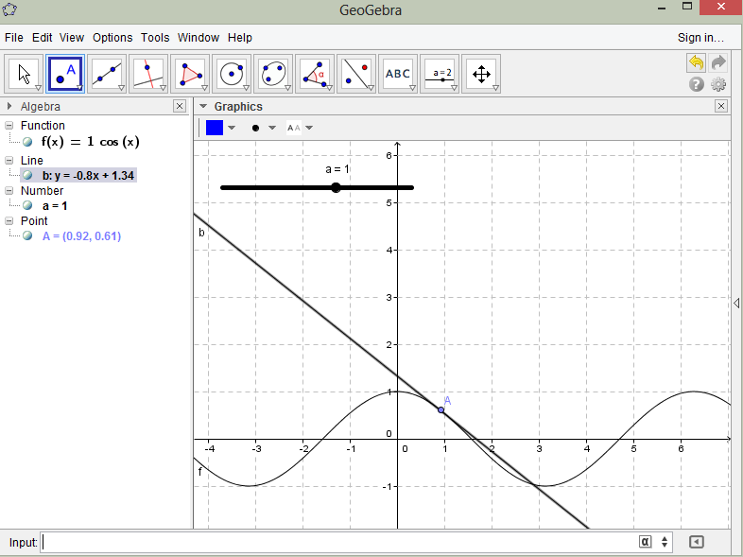

STOP AND THINK!!!!!!
- What is a tangent line?

- What is a derivative?

- How do we find the tangent line to a curve algebraically?

- What is the slope of f(x) at the following locations:
  - 0 _______
  - $\frac{π}{2}$ _______
  - $π$ _______

Step 7: Create a unique point B. Go to the input bar and type the following command:
B=(x(A),slope[b]) (Note: x(A) represents the x-coordinate of point A, and slope[b] represents the slope of the tangent line)
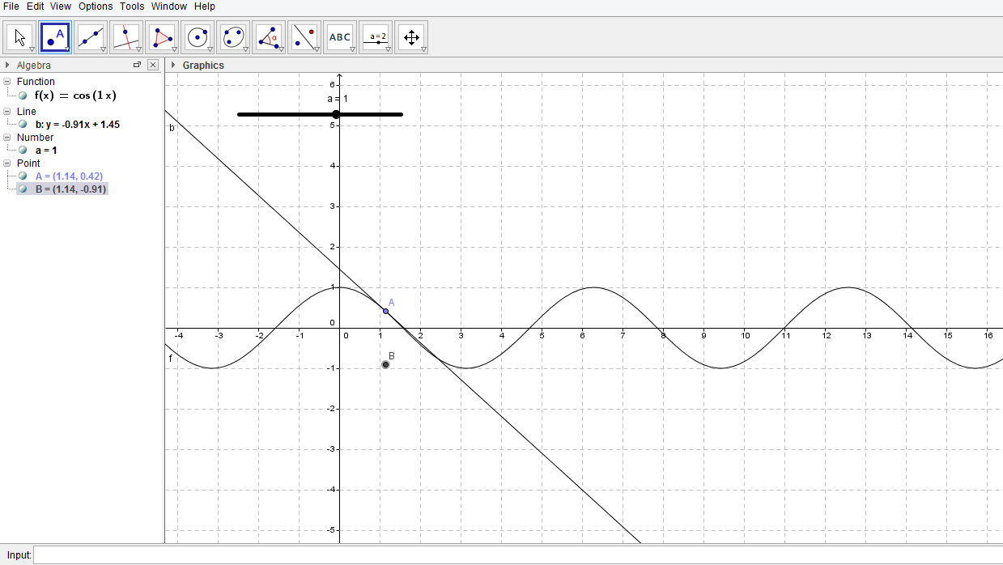
Then press enter and compare your screen with the snapshot below:

Step 8: Right click on point B and wait for the mini-toolbar to appear. Once the mini-tool bar click on “trace on.”

Step 9: Click on the arrow button, 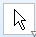, on the top left hand corner of the screen, and then click on point A to move it along the sign curve. Notice that you are now drawing the derivative function. Your screen should look similar to the snapshot below:
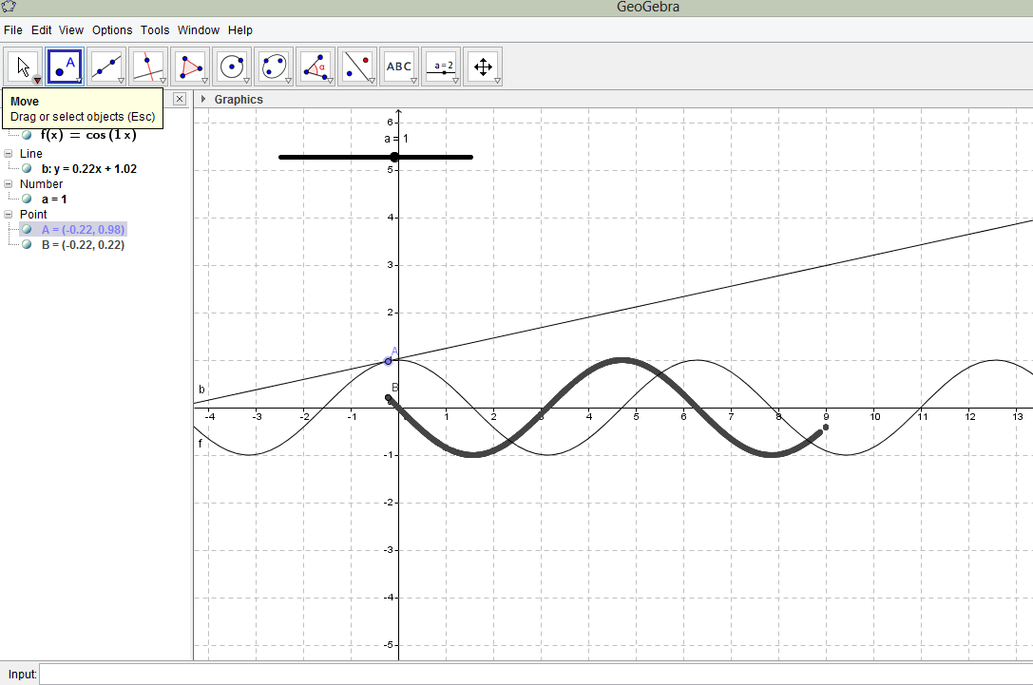

Discussion Questions

- What of the following graphs displayed is the graph of our function? Which of the following graphs displayed is the graph of the derivative function?

- Algebraically, if f(x) = cos(x), then what is f’(x)?

- Describe and explain the points on the derivative curve that correspond to turning points on the original function.

- What does the “a” represent in the function f(x)=(a)cos(x)? Use Geogebra to determine what happens when you change the value of “a.”

Exercises!!!
Directions: Using the concepts discussed in this lesson, construct a tangent line to a point on each of the following functions. Then, using the commands you just learned construct a graph of the derivative.

- f(x)=2sin(x)

- f(x)=3cos(3x)

- f(x)=sin($\frac{1}{2}$x)

- f(x)=tan(x)

**Using the information presented in this lesson, start with the function f(x)=sin(x). Before graphing the derivative function, make predictions about what the graph of the derivative will look like. (Hint: What is f’(x) when f(x)=sin(x)?)

